Project Design Phase
Solution Architecture

Date | 10-02-2026
Team ID | LTVIP2026TMIDS65437
Project Name | Flavour Fusion: -Ai-Driven Recipe Blogging
Maximum Marks | 5 Marks

Solution Architecture:
The solution architecture for Solution Architect for an AI-driven "Flavours Fusion" recipe blogging project bridges the gap between culinary innovation and technical execution. The primary goal is to build a scalable, AI-powered platform that generates, tests, and publishes creative, fusion-style recipes and images, while optimizing for SEO and user engagement.
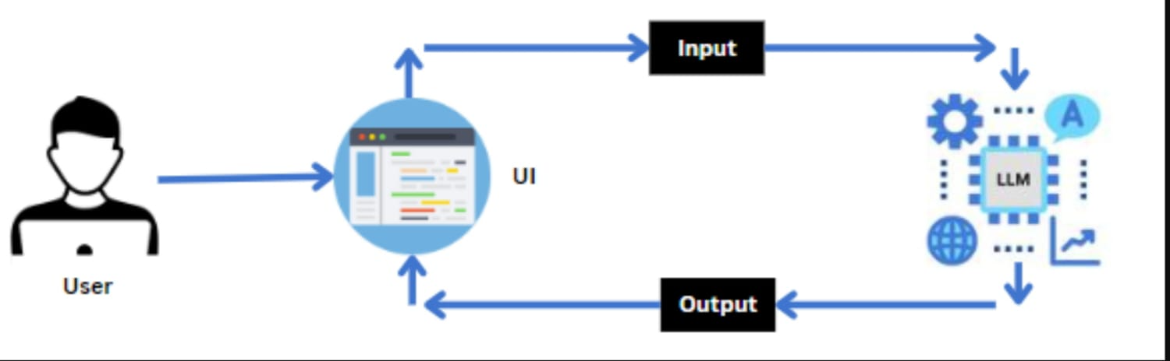
Here is the proposed architectural solution and strategic roadmap for this project.
1. Project Vision & Core Functionalities
The Platform will automatically generate, visualise, and publish unique fusion recipes (e.g., "Miso Tacos") by blending ingredients, techniques, and culinary cultures.
AI Recipe Generator: Creates unique recipes based on ingredient inputs, dietary constraints, and theme prompts.
AI Visualizer: Generates photorealistic food images from text descriptions or rough sketches.
Automated Blogging Platform: Integrates with CMS (e.g., WordPress) to publish, tag, and optimize recipes for SEO.
"Flavours Fusion" Engine: Leverages Large Language Models (LLMs) to identify complementary tastes from different cuisines.
2. Proposed Technical Architecture
A serverless, API-driven architecture is recommended for high scalability and low maintenance.
- Frontend/CMS: WordPress (with SEO plugins like RankMath) or a headless frontend (React/Next.js) for high performance.
- Automation Engine: Pabbly Connect or Make.com to connect triggers (e.g., weekly topic) with OpenAI and CMS.
- AI Brain (LLM): GPT-4o or Claude 3.5 Sonnet for detailed, creative recipe generation and instruction coherence check.
- Image Generation: Midjourney, Stable Diffusion (via API), or SideChef Studio for high-quality, realistic food imagery.
- Vector Database (RAG): Pinecone or pgvector to store existing recipes, ensuring the AI generates new ideas rather than repeating known ones.
- Data Storage: PostgreSQL for structured data (ingredients, nutritional data, user profiles).
3. Solution Architect Responsibilities
- Component Interoperability: Ensuring the AI, Database, and WordPress CMS work seamlessly together.
- Scaling the Platform: Planning for increased user traffic and high-volume image generation.
- Data & AI Security: Implementing RAG (Retrieval-Augmented Generation) to ground AI in reliable culinary data, reducing hallucinations.
- Cost Optimization: Selecting the right APIs (e.g., using GPT-3.5/4o-mini for draft creation, 4o for final polishing) to keep per-recipe costs low.
4. Implementation Roadmap
- Phase 1: Prototyping (Weeks 1-2): Set up OpenAI API connection with a "Fusion-Focused" prompt template. Test with manual image generation (Midjourney).
- Phase 2: Automation (Weeks 3-4): Use Pabbly/Make to connect the AI output directly to a WordPress draft.
- Phase 3: RAG Implementation (Weeks 5-6): Build a vector store of 1000+ top recipes to allow the AI to "understand" flavour combinations and prevent repetitive content.
- Phase 4: Launch & Optimize (Weeks 7+): Integrate analytics (Google Analytics) to track which fusion styles gain the most traffic.
5. Key Non-Functional Requirements
- Performance: Fast loading times for image-heavy pages.
- SEO Reliability: Ensuring generated recipes include SCHEMA markup (Recipe JSON-LD) for rich search results.
- Maintainability: Using modular, containerized components (Docker) if bespoke development is used.

Example for Solution Architecture: -
Solution architecture for “Flavour fusion:- Ai-Driven Recipe Blogging”

